

**LaVision Light Sheet Microscope Protocol for DBE-cleared Sample**

1. **System Startup**
   * Please note sign-up policy. You must inform the facility at least 24 hours beforehand if you can’t come; otherwise, you will receive a charge for unused time. The facility will allow for extenuating circumstances (cells dying, sick day, etc.) if you inform us in a timely fashion.
   * Follow each step of the startup poster and wait for the microscope software to fully load.
2. **Lens Cleaning**
   * Please **clean the lenses** **before and after** your session. Use methanol for organic solvent dipping lens. Refer to the lens cleaning poster if you need any help recalling the rules and steps.
3. **Microscope Control**
   * Take note of the microscope light path:
4. Light source
5. Light sheet beam path
6. 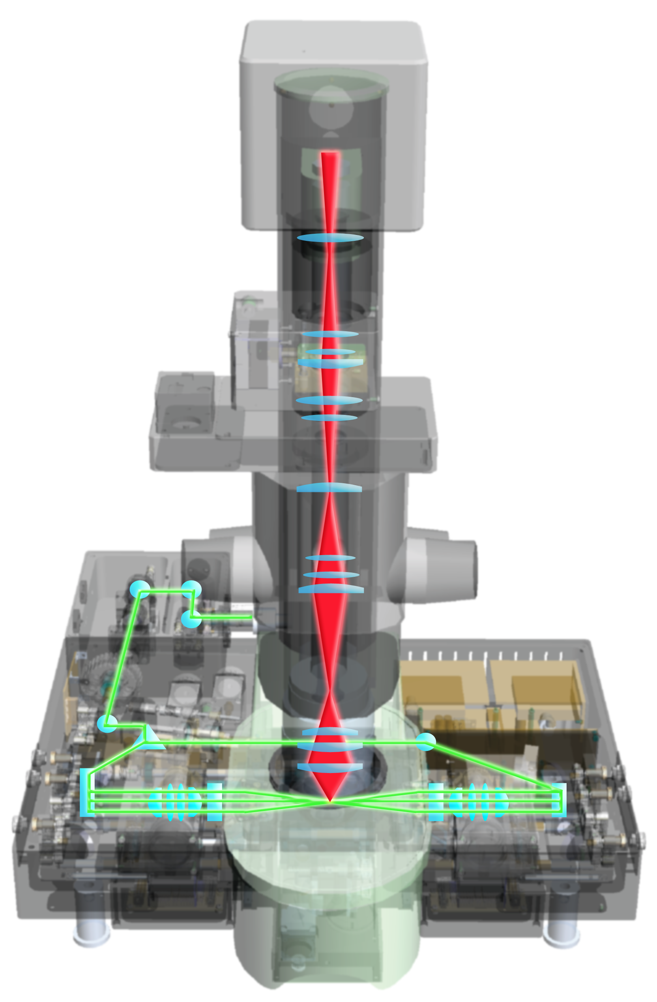Focus knob
7. Lens position
8. Sample cuvette
9. 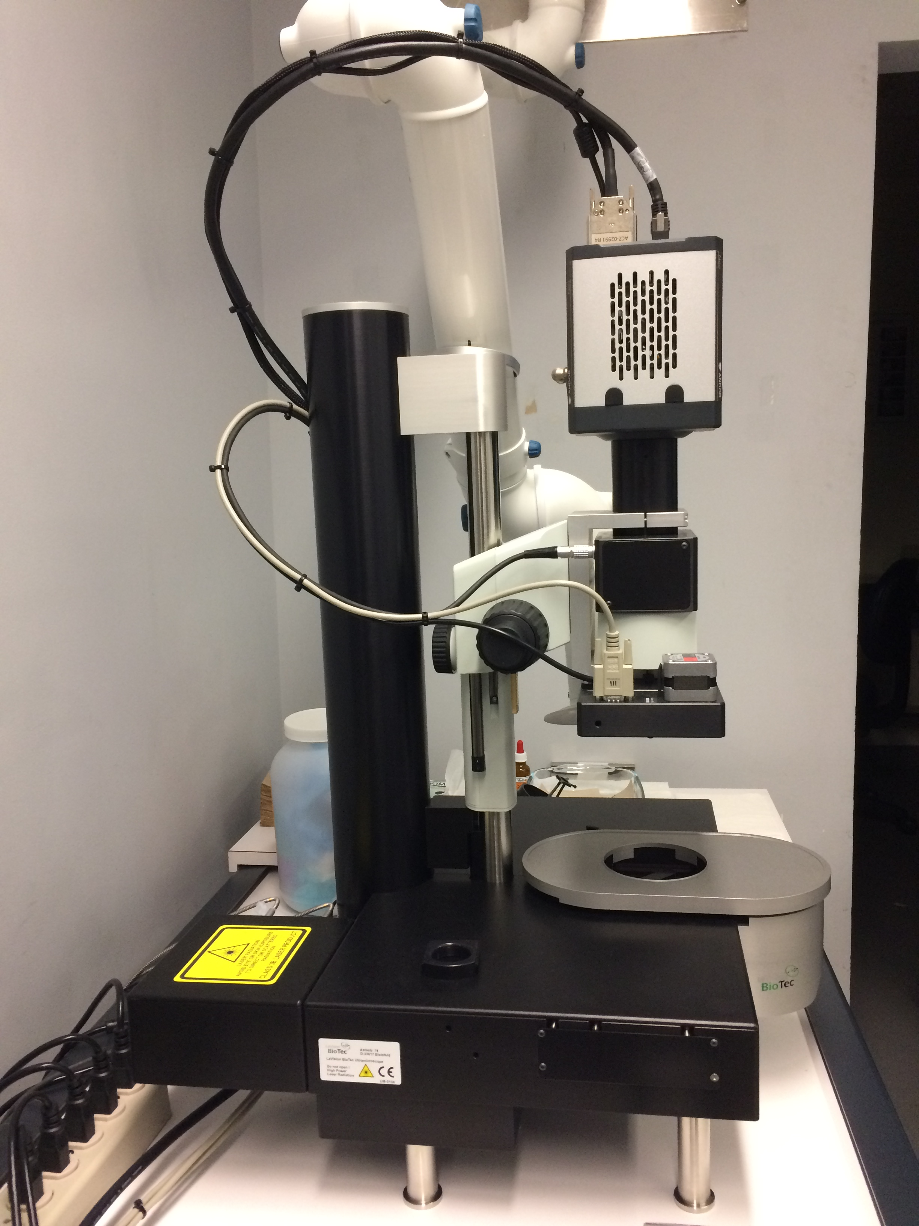Camera

A

B

C

D

E

F

* + Sample stage control
    - Use the dial to find your region of interest
    - Use the highlighted button to toggle between control speeds.

Z

X

Y

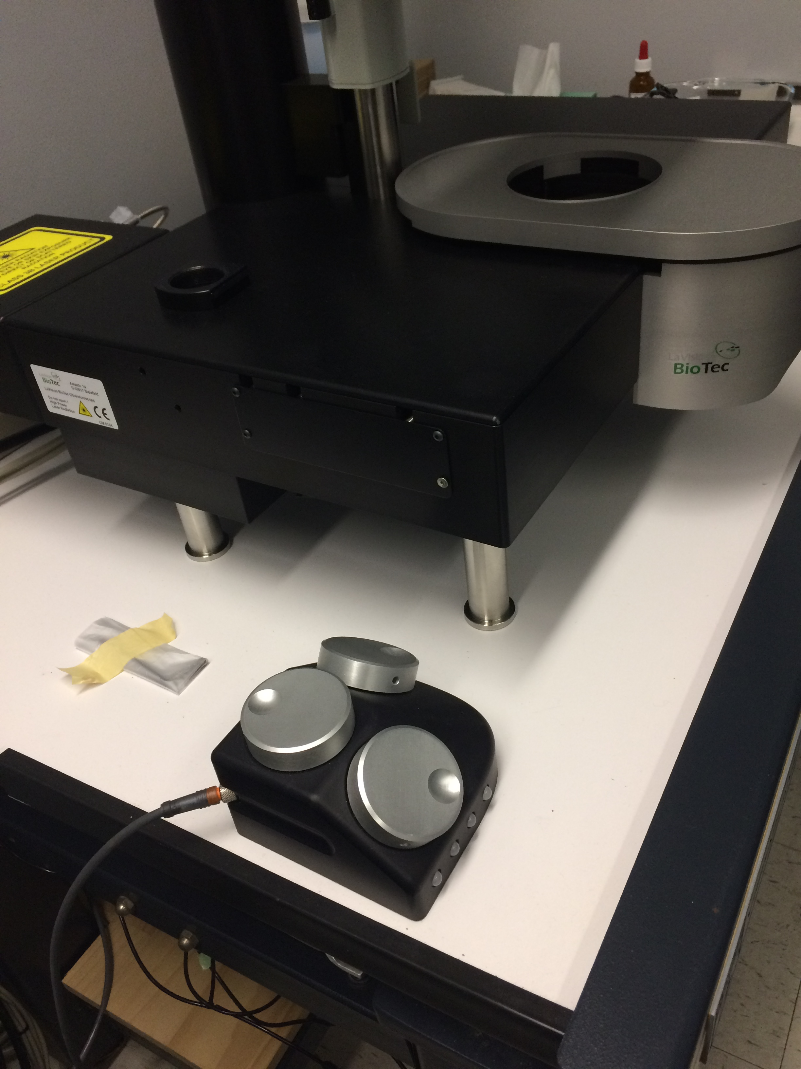

* + Focus Control
    - Course and fine focus control are located on both sides of the microscope.
    - Focus on the top of your sample using focus knob. Once in focus, check ROI with different Z-position by dialing the Z-wheel (**not the focus knob**). Check all channels before imaging.

1. **Software Control**
   * Open the ImspectorPro Software
     + Click “OK” or “Cancel” to turn on the 561nm laser or not.

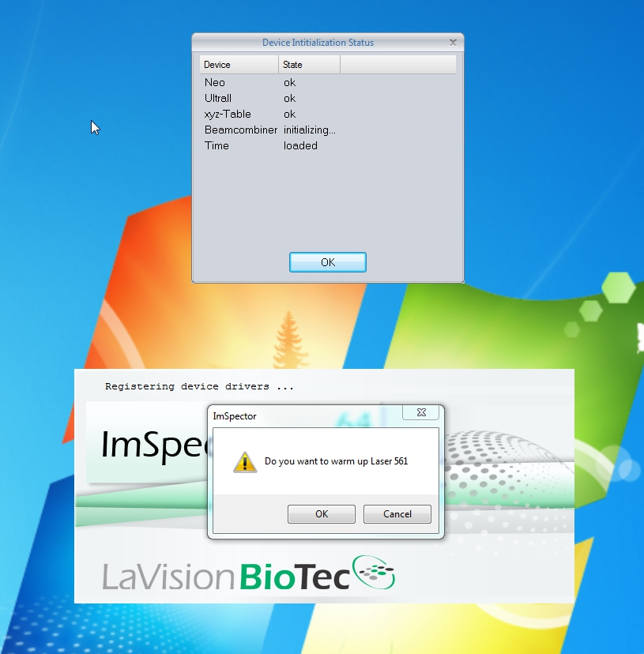

* + Upon completed startup, please note the 6 divisions of the interface:
    - Left: Acquisition control panel
    - Middle:
      * Top: Light sheet control panel and tiling setup panel
      * Middle: Horizontal dynamic focus setup panel
      * Bottom: Z-stack setup panel
    - Right: image preview and acquired image

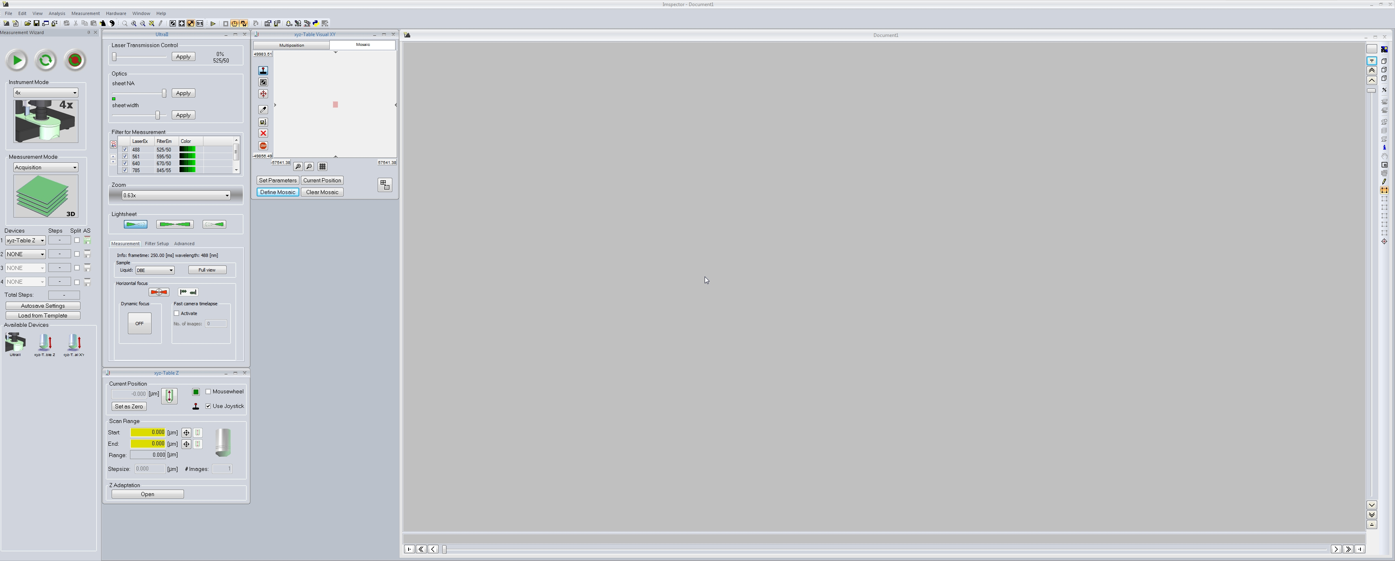

**Tiling Panel**

**Preview**

**Window**

**Display**

**Window**

**Acqui--sition Panel**

**Z-stack Panel**

**Light Sheet Panel**

**Dynamic focus Panel**

1. **Mount your sample (DBE protocol)**

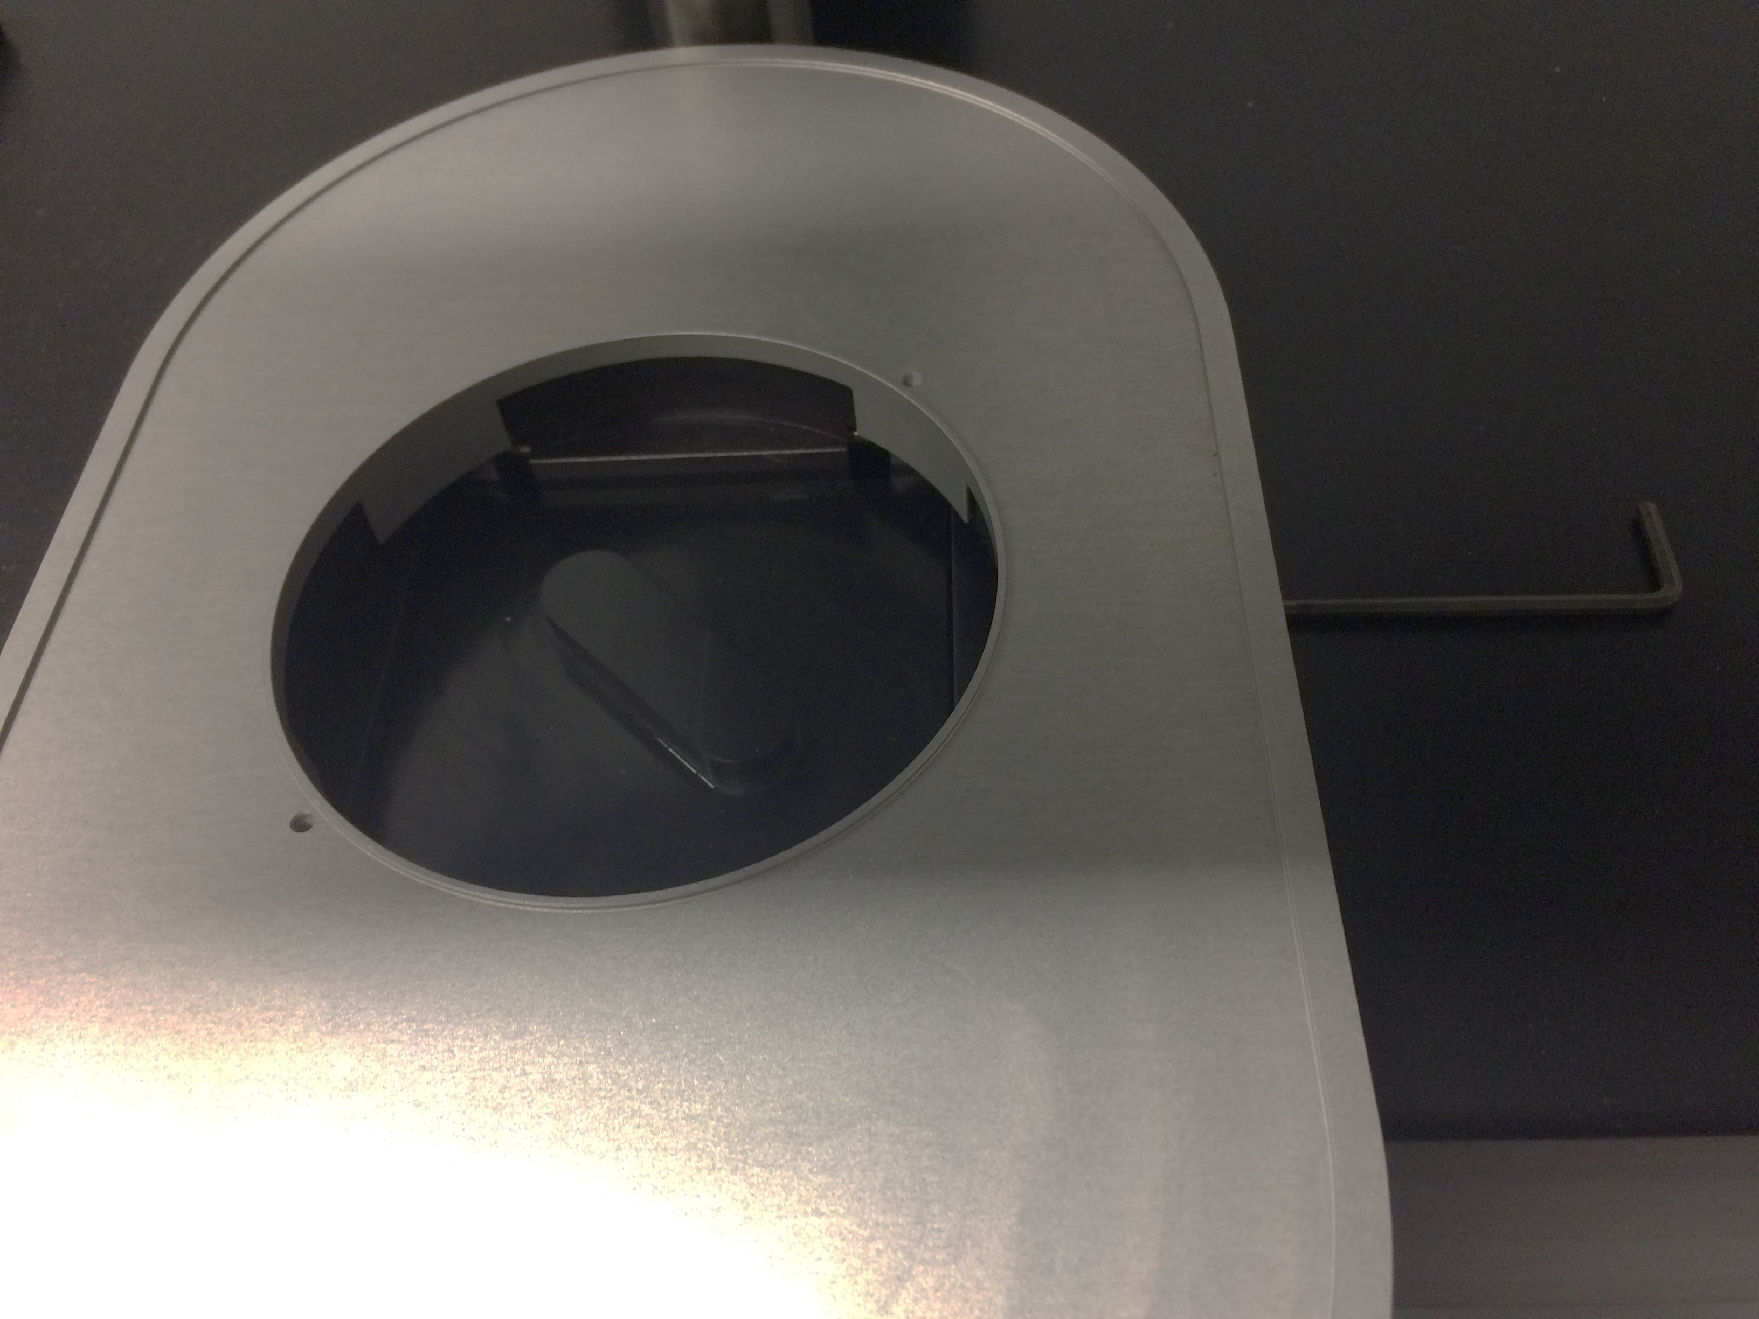

**Lid**

**Stainless steel plate**

* + Use the Allen key to unlock the stainless steel plate. Take it off allowing access to the DBE cuvette lid.
  + Wear fresh glove and operate in the chemical hood.
  + Sample holder and scaffold sit on clean paper towel in the pyrex tray.

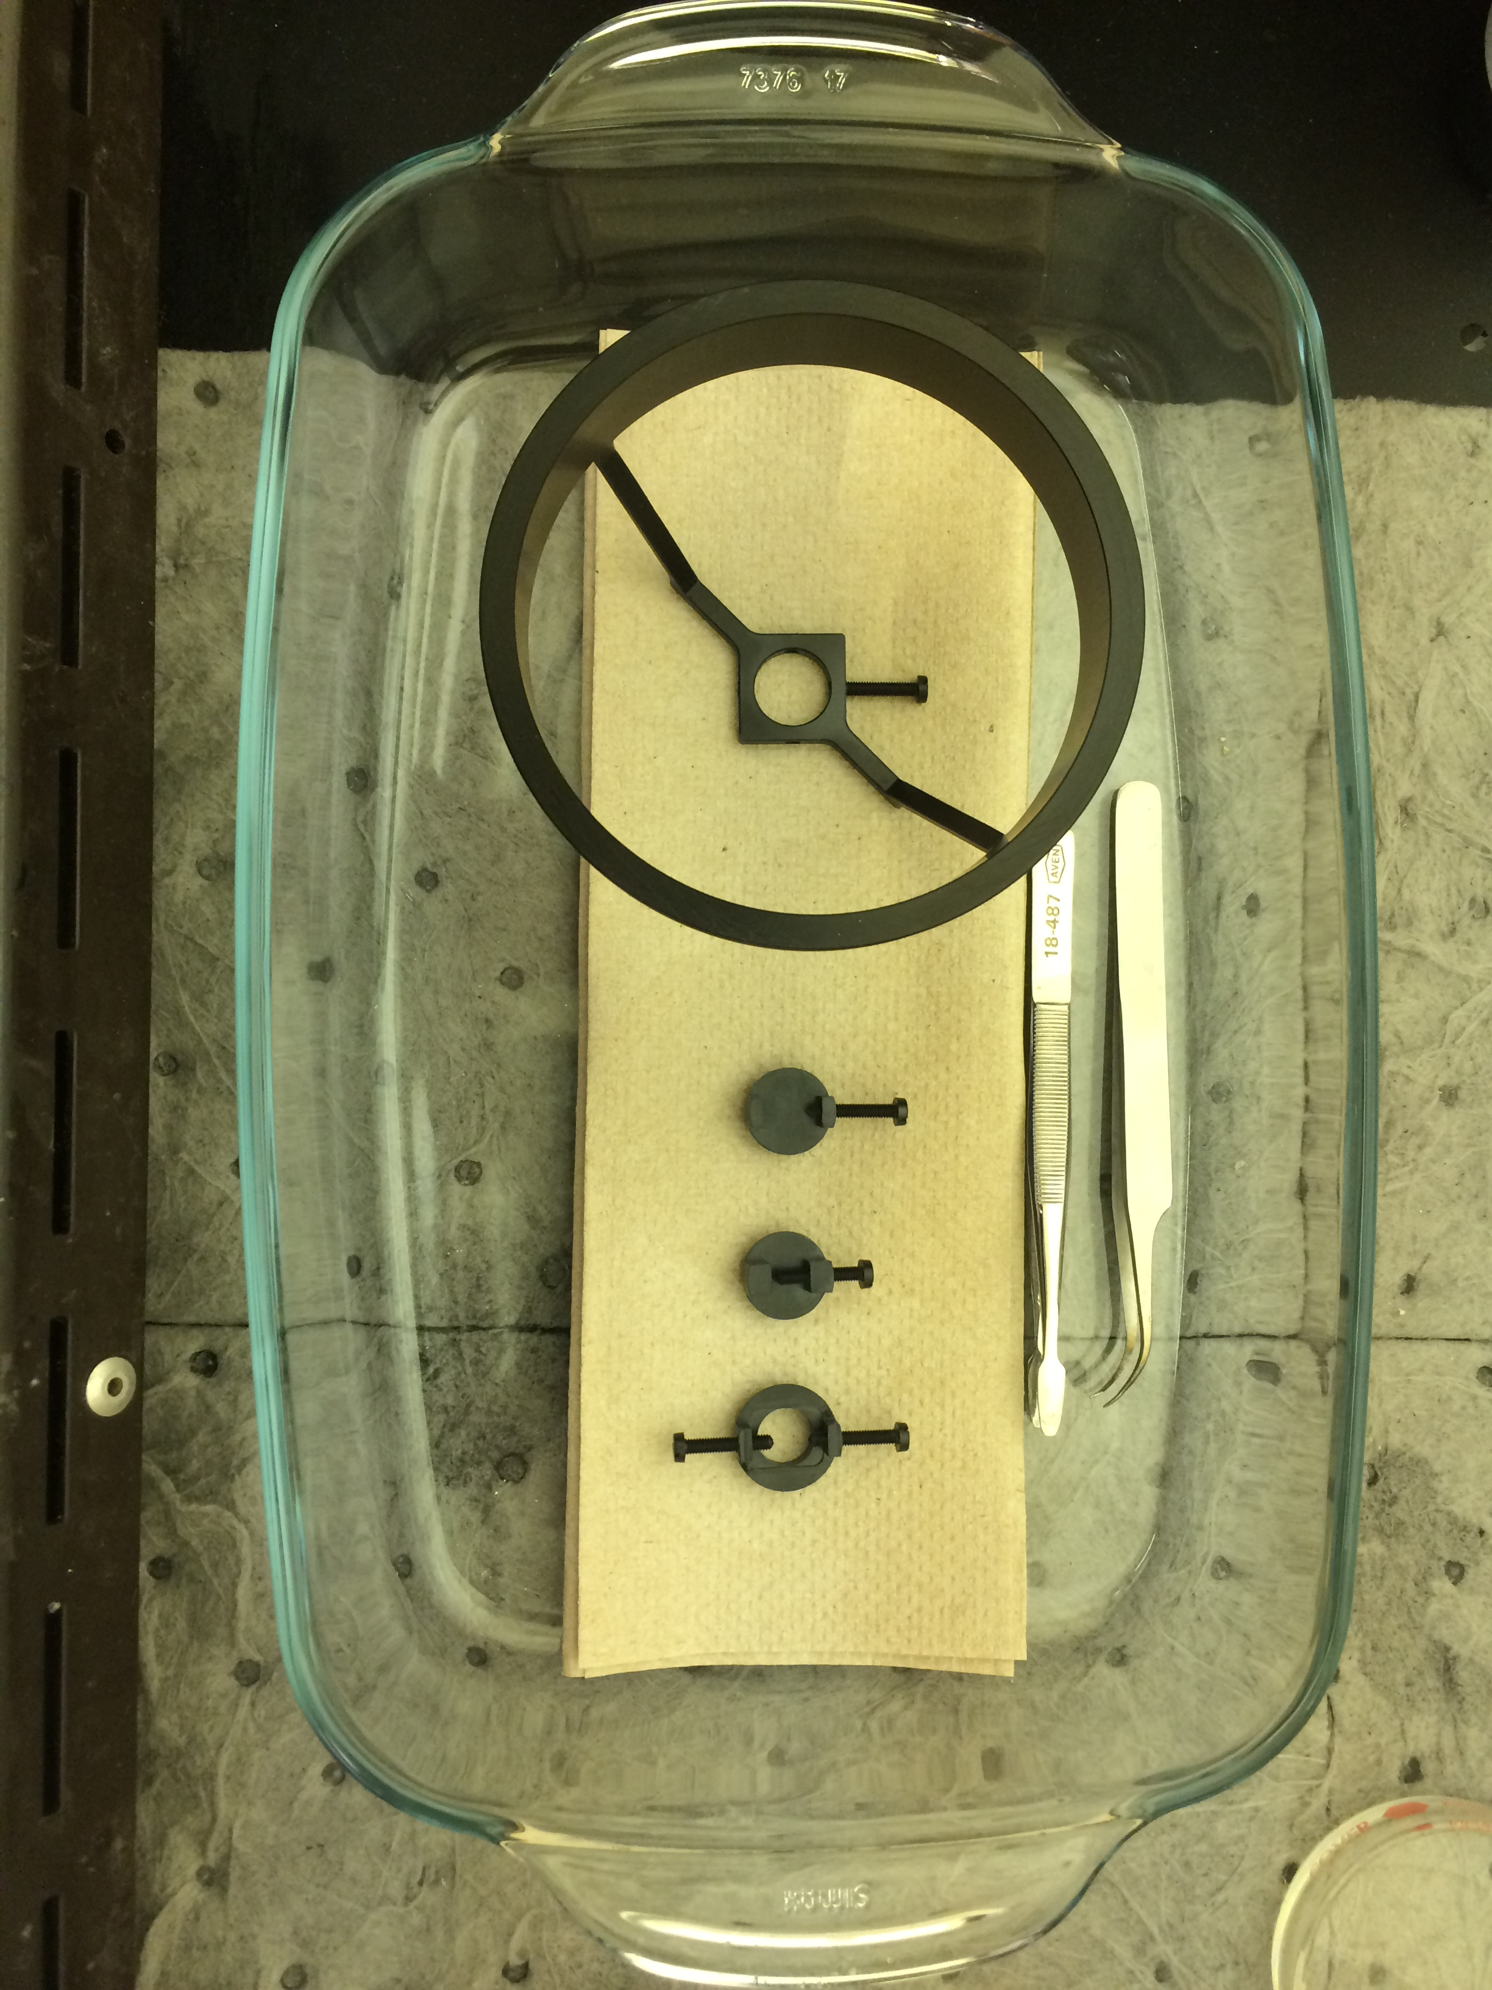

**Sample holder**

**Scaffold**

* + Transfer DBE-cleared sample onto sample holder using tweezers. Finger-tighten the screw to restrain sample.
  + Put the sample holder into the scaffold and transfer the pyrex tray next to the microscope.
  + Pick up the cuvette lid and rest it on paper towel in the pyrex tray. **Use caution to prevent DBE spill or dripping.**
  + Remove glove and trash them in the DBE waste container. **Proceed without glove.**
  + Put back the stainless steel plate. Lock it.
  + Transfer the scaffold into the cuvette. Rest it on the stainless steel plate. Keep the screws out of the Light sheet beam path (See below). **Use caution to prevent DBE spill or dripping.**

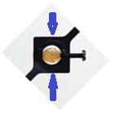

1. **Mount the lens**
   * Contact staff for the use of specific lens.
   * Remove the lens from the plastic housing.
   * Attach the adapter to the base of the lens. Pay attention to the “front side”.

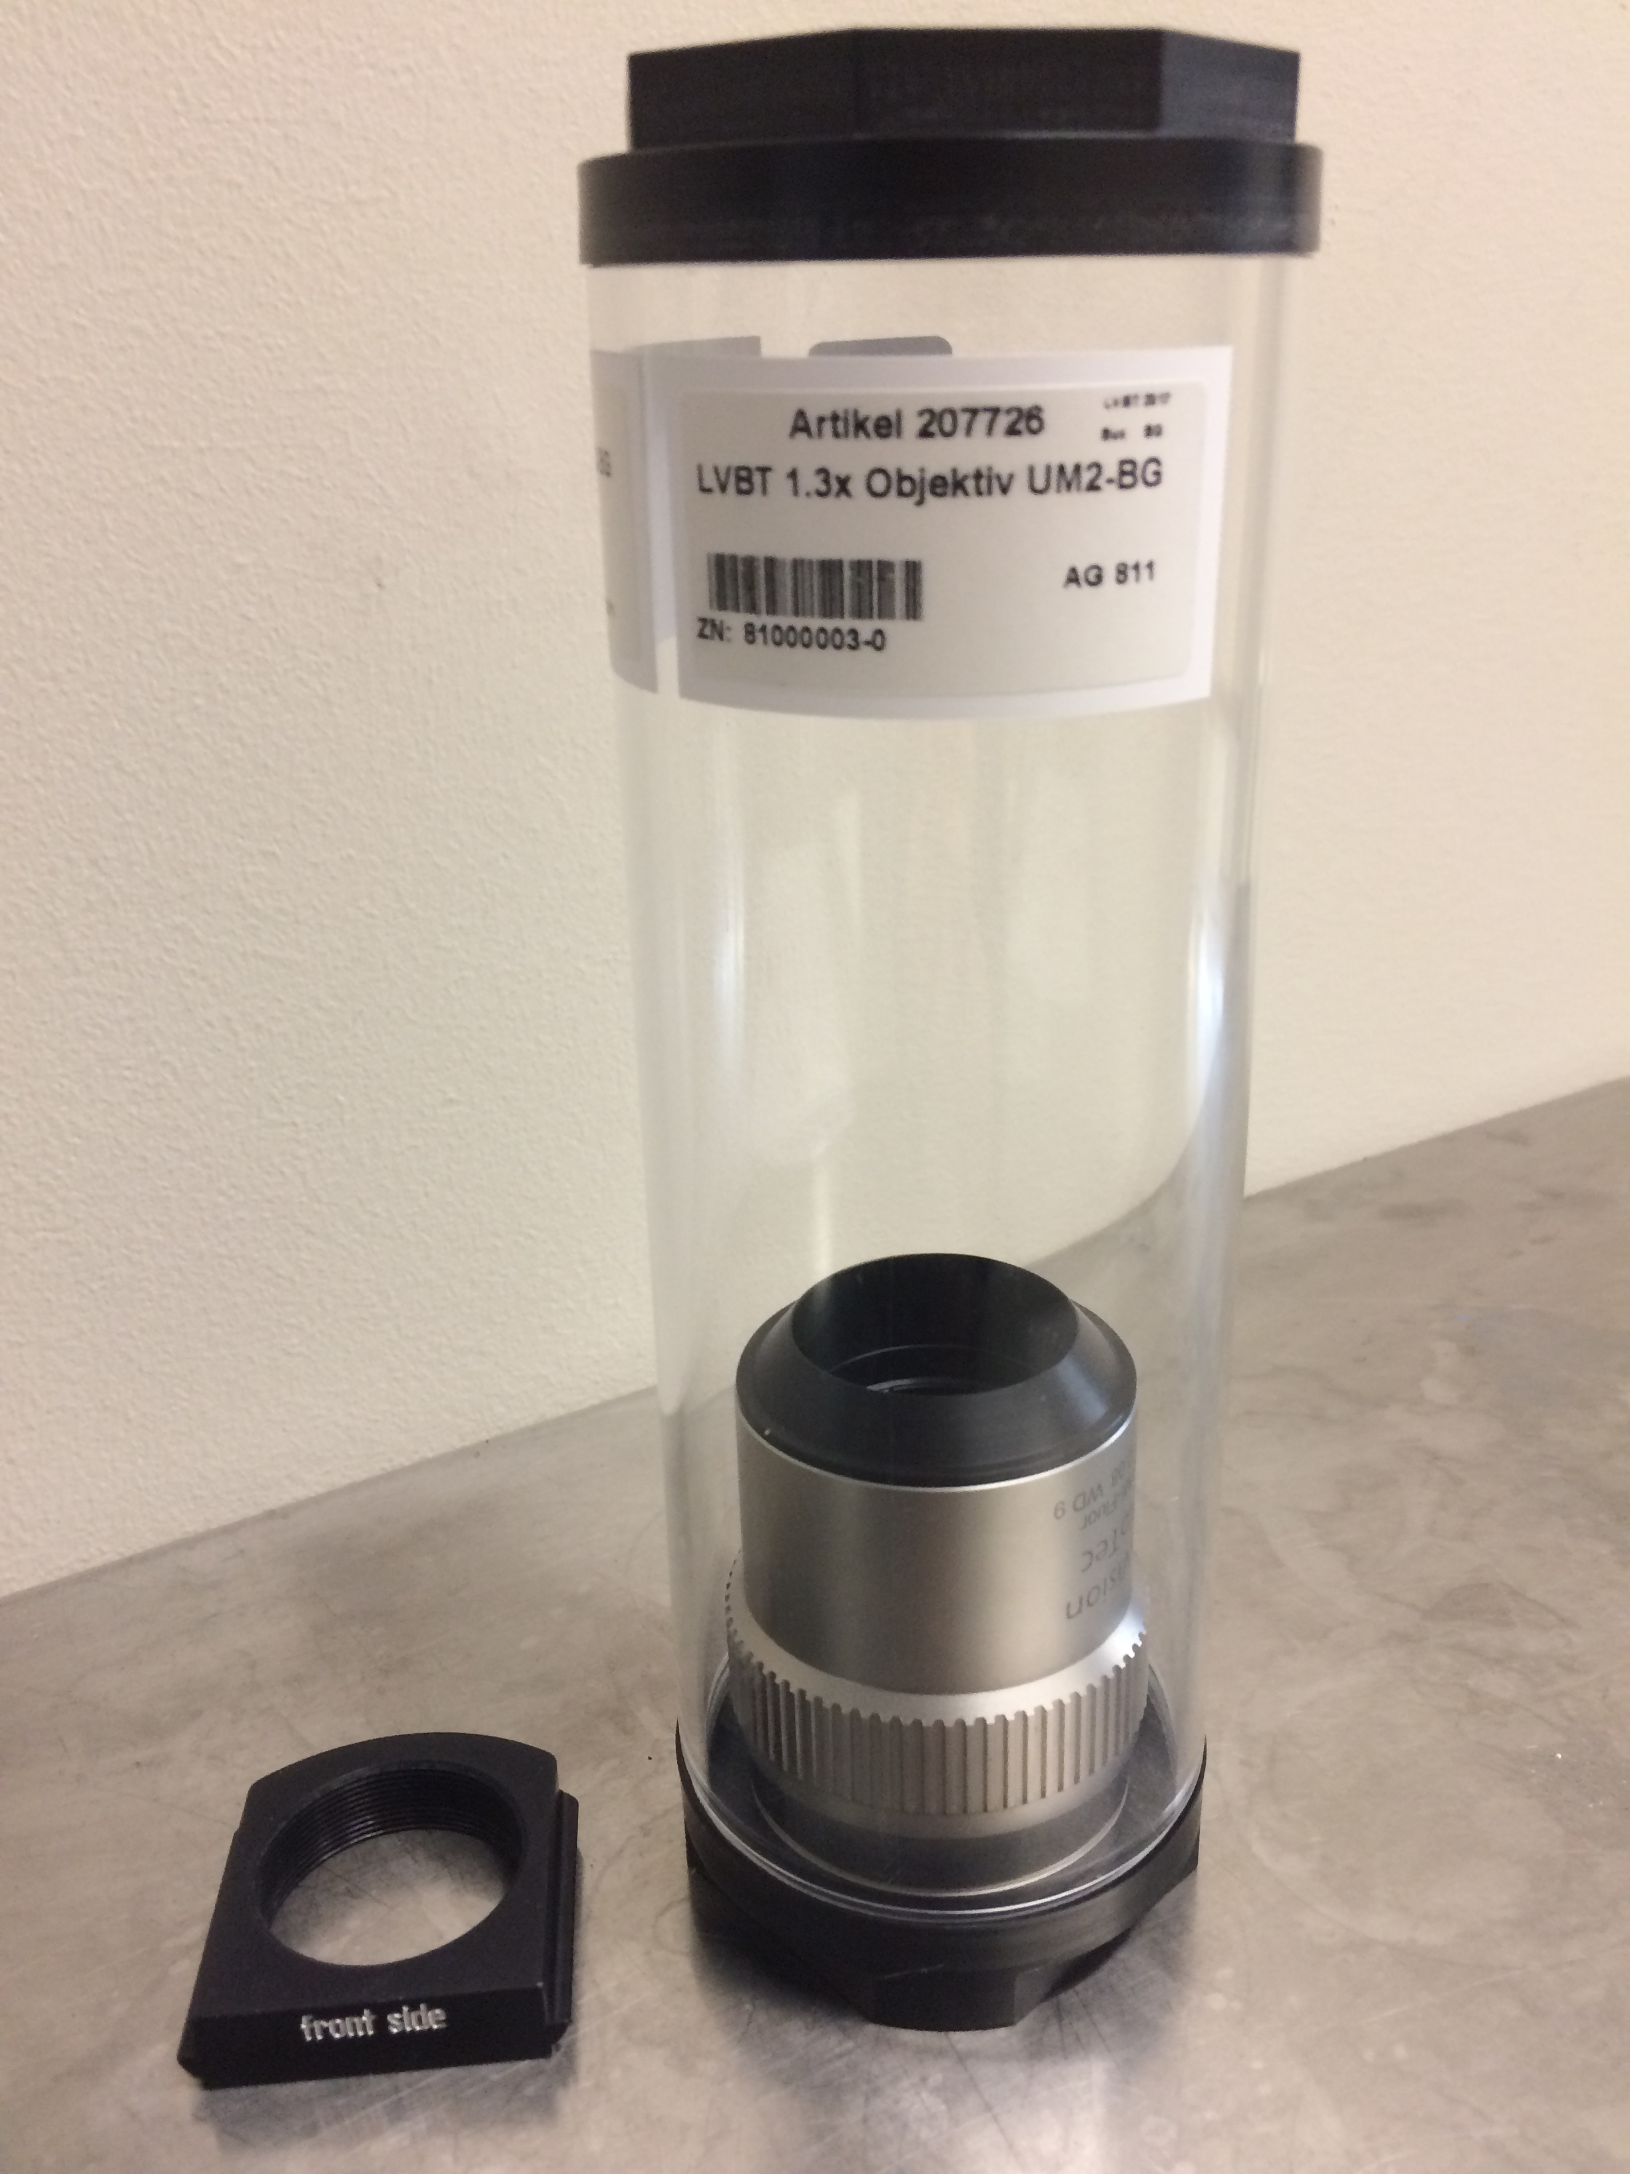 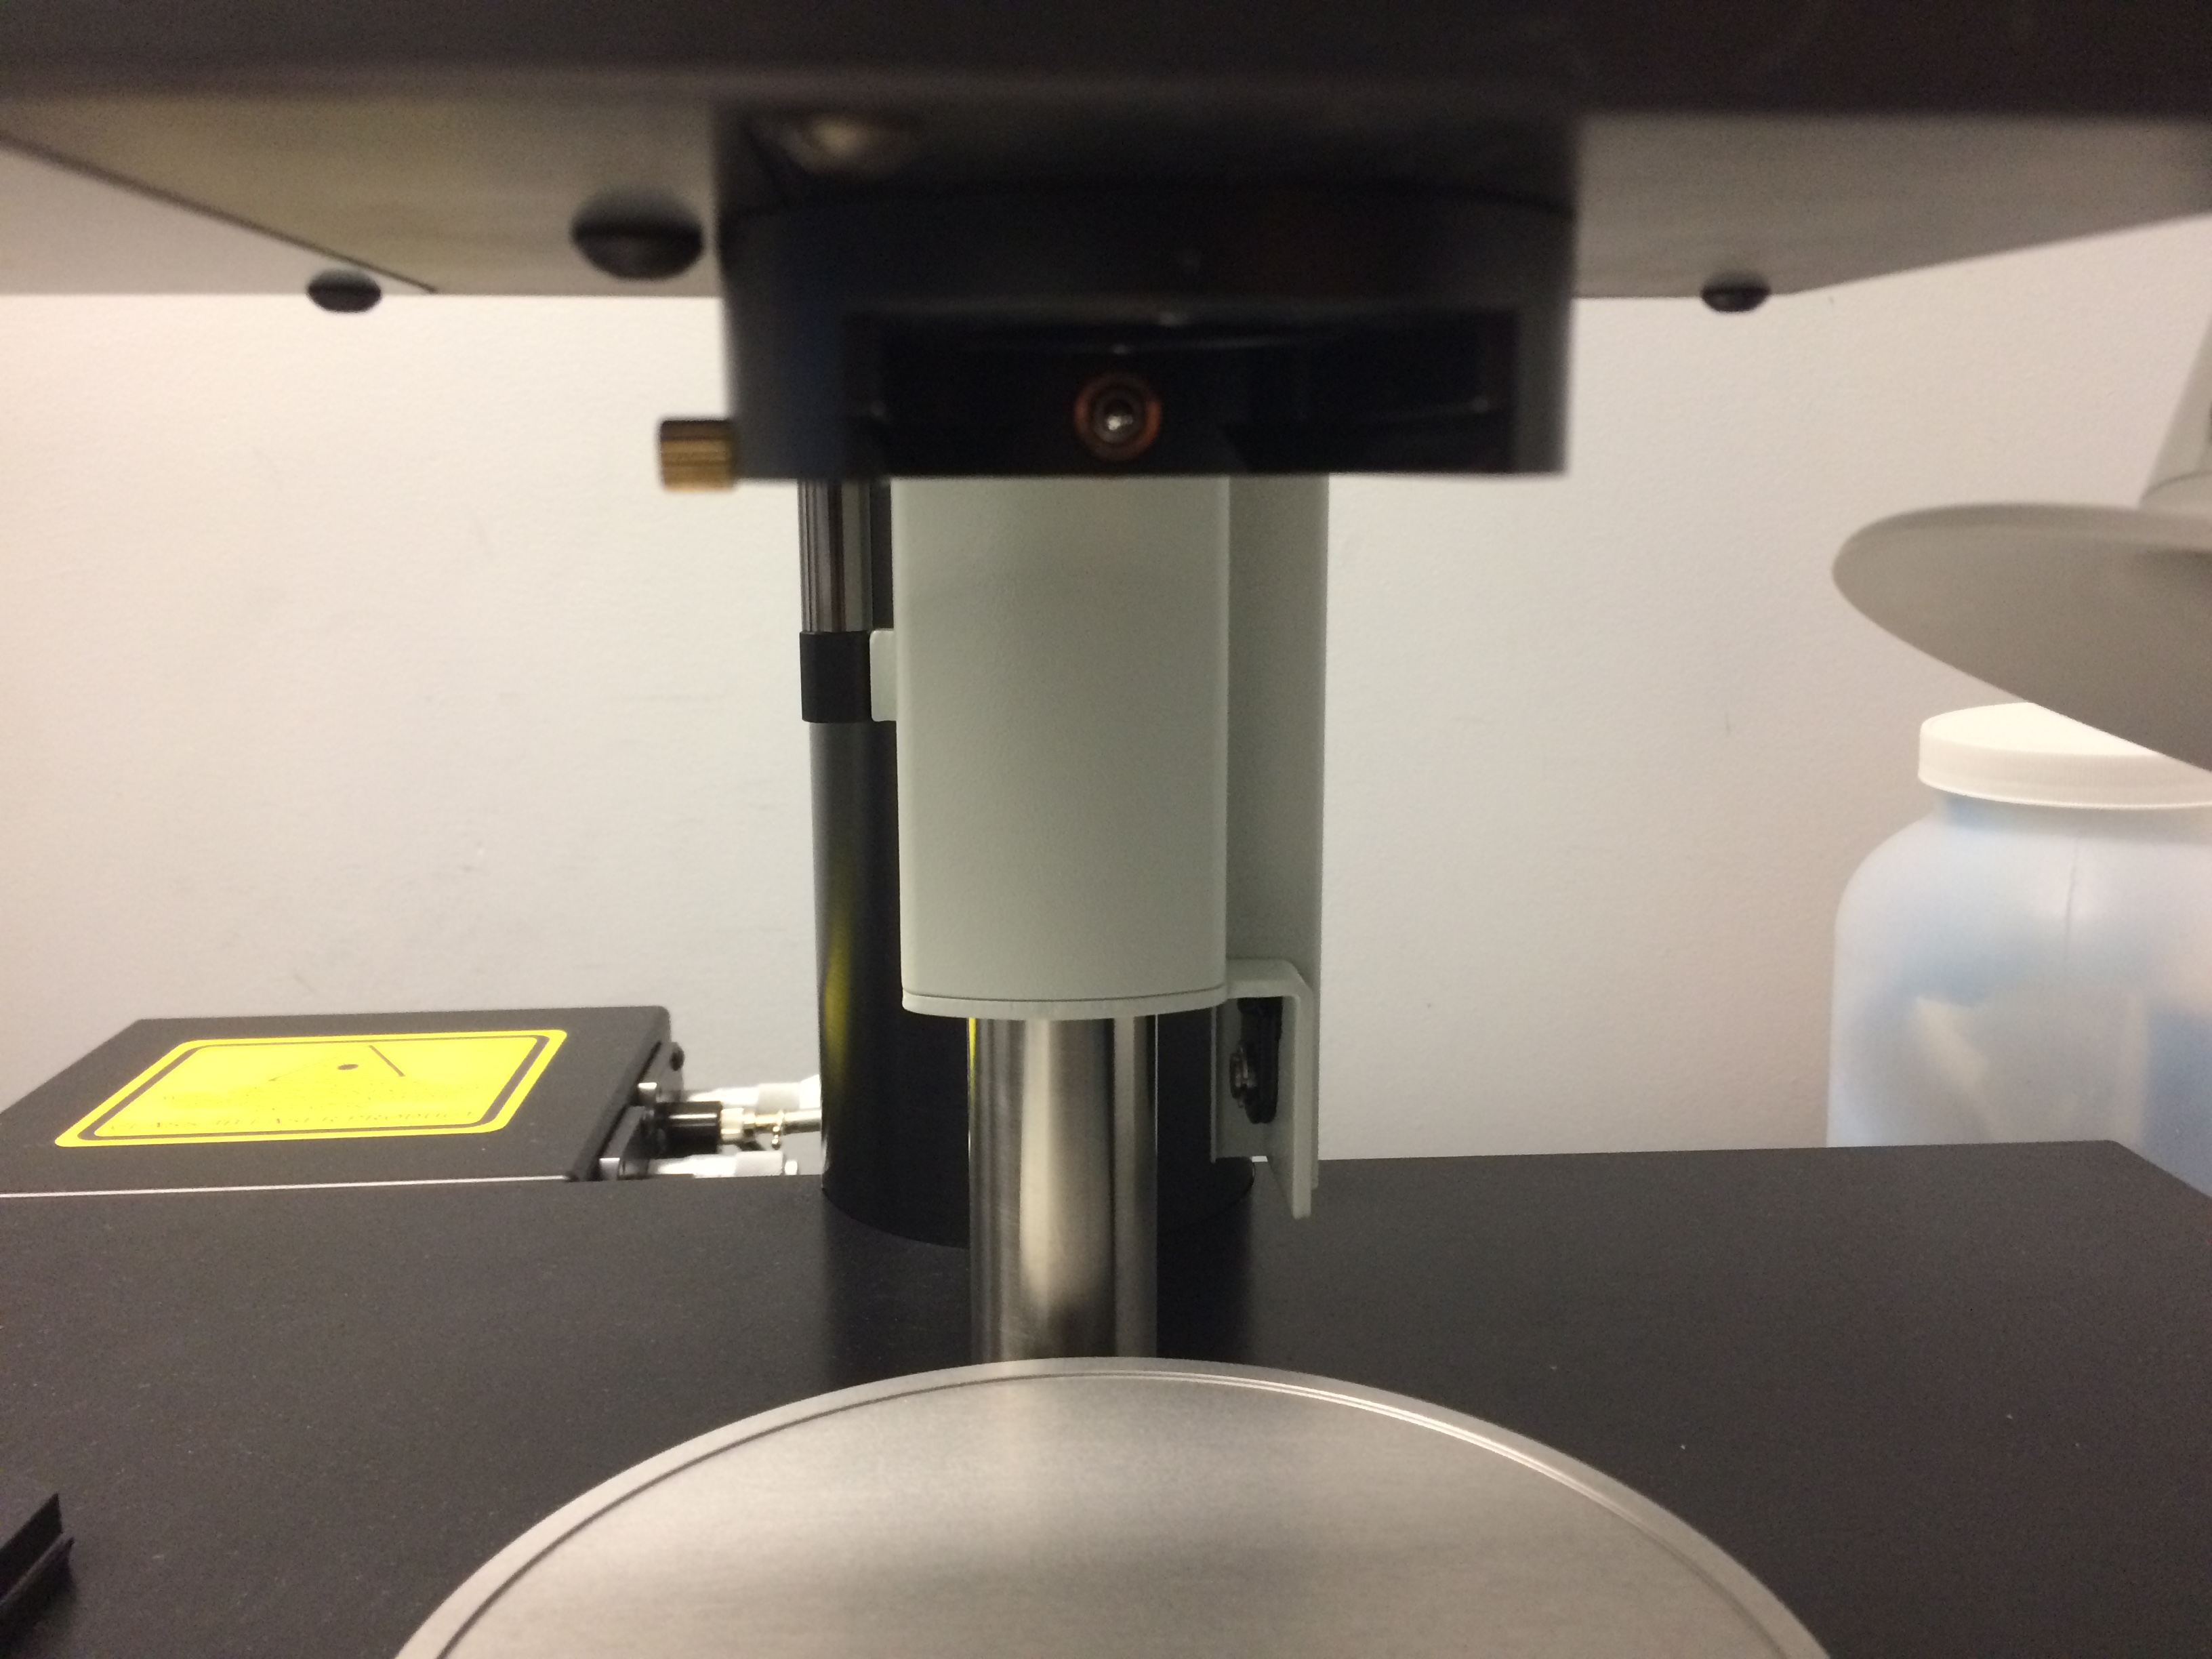

**D**

* + Slide the adapter and lens into the lens position (D) and lock it with the screw.

1. **Find ROI**
   * Set the correct lens (e.g. 1.3x), zoom (e.g. 1x), and liquid (e.g. DBE) in InspectorPro.



* + Choose the laser wavelength by checking the box.
  + Set the power, light sheet width and NA in the Light sheet control panel. E.g. 6% transmission, sheet NA = 0.2, 50% sheet width.
  + Click “Live” and adjust focus knob to find ROI.
  + Define ROI by activating rectangle tool and draw a box in preview window.
  + Toggle between F9 and F10 key to reset display brightness.
  + Focus on the top of your sample using focus knob. Once in focus, check ROI with different Z-position by dialing the Z-wheel (**not the focus knob**).
  + Check all channels before imaging. Set **chromatic offset** if needed.

 

1. **Chromatic correction**
   * For higher magnification lens (4x and up), use **“chromatic correction”** function to correct difference in focus due to different emission wavelength.
   * 488 laser is the default reference channel. Highlight the 488 laser and adjust focus in live view.
   * Activate the “**chromatic correction**” panel by clicking the top left button in the laser control panel.

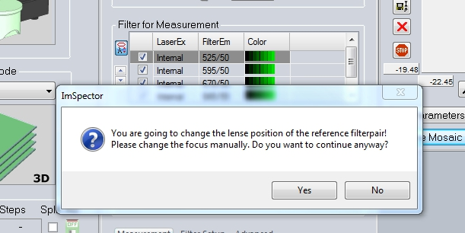

* + Click “Yes” in the popup dialogue window.

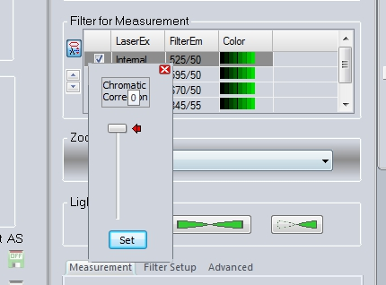

* + Use the scroll bar to fine tune the default focus in the 488 reference channel. This function also gives extra room for Z-focus when reaching the lower limit of the focus knob.
  + Click “Set” and then close the scroll bar.
  + Once an optimal Z is determined for reference channel (488 as the default), proceed to determine the chromatic offset for other channels. Highlight other laser channels and activate the “**chromatic correction**” panel. Use the scroll bar to fine tune the focus in other channels. Click “Set” and close the scroll bar window.

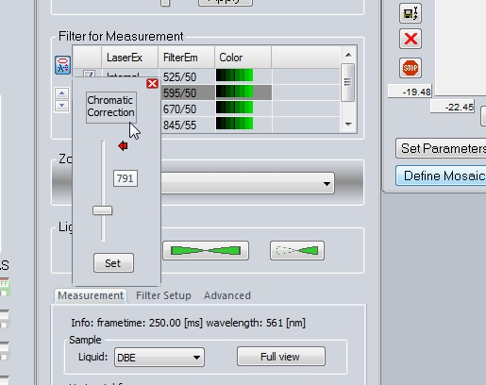

1. **Set up Z-stack**



* + Once in focus, use sample stage dial (Z) to check ROI with different Z-position.
  + Set zero position.
  + Go to the bottom of the sample, set as end. Then go back to the top of the sample, set as start.
  + Use step size, 5 µm, for high resolution imaging (E.g. high light sheet NA and narrow width). Or larger step size for quick 3D overview of large sample (E.g. low light sheet NA and large width).
  + Click “STOP”, to end live view.

1. **Acquisition and Autosave option.** 
   * Select “Multicolor 3D” from Measurement Mode drop down.
   * Under “Devices”, select 1) xyz-Table Z, 2) Ultrafilter.
   * Click autosave button (click Device one, activate all). Uncheck “Split” for Device 1 “xyz-Table Z”, only check “Split” for Device 2 “Ultrafilter”.
   * Click “Autosave Settings”.
   * In dialogue window, enter folder path to save data to Y: drive. Enter name and “_” at the end. Keep other options as shown.
   * Click “Advanced settings”.
   * In dialogue window, check “Add meta data only to first image of series”, uncheck “Use fast autosave with streaming”.
   * 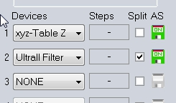Click “OK”, then click “OK”.
   * Click “Start” to initiate multicolor 3D imaging.

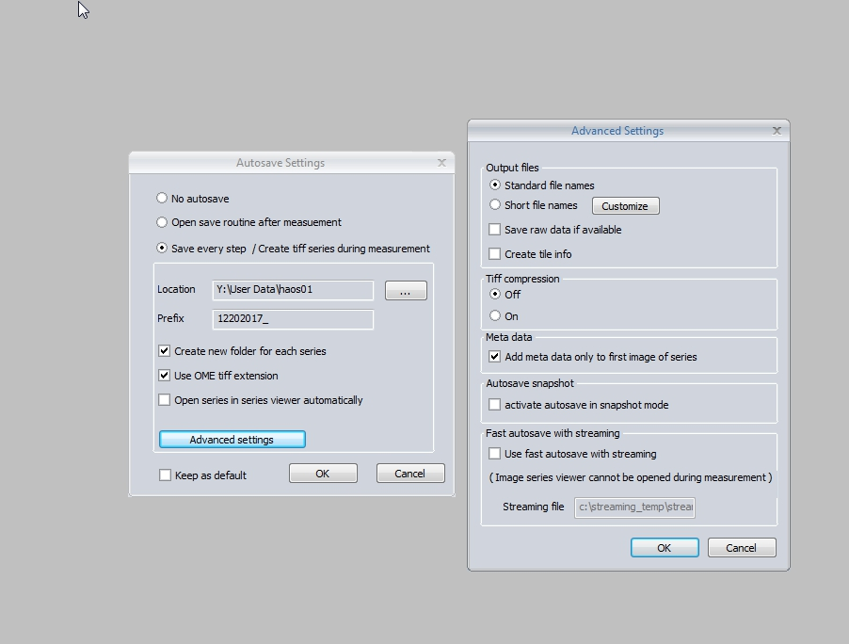 



**5**



**3**

**4**

1. **System Shutdown**
   * 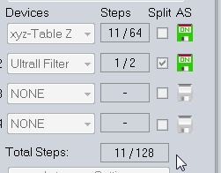Check the result folder for acquired images once finished. The total number of images should match the total steps calculated based on your imaging sequence.
   * Loosen the screw. Dismount the lens and adapter. Remove the adapter.
   * **Only in the case of DBE dipping lens**, wear glove and use methanol/lens paper to clean the lens. DO NOT TOUCH other part of lens with DBE-contaminated glove during cleaning.
   * Remove the scaffold from DBE cuvette. **Use caution to prevent DBE spill or dripping.**
   * Reverse the sequence to dismount sample from the sample holder.
   * Clean the sample holder and scaffold bottom with a few drops of methanol. Wipe clean using Kimwipes. Dispose the waste and glove in DBE waste container. (One in the fume hood, the other one next to the microscope. Notify staff when the containers are full.)
   * Proceed without glove. Follow shutdown poster steps.